AWS Practical 1 : Launch a web server over LINUX EC2 instance

Step 1. Create an Ec2 Instance

1. Select a desired Ec2 Instance Name

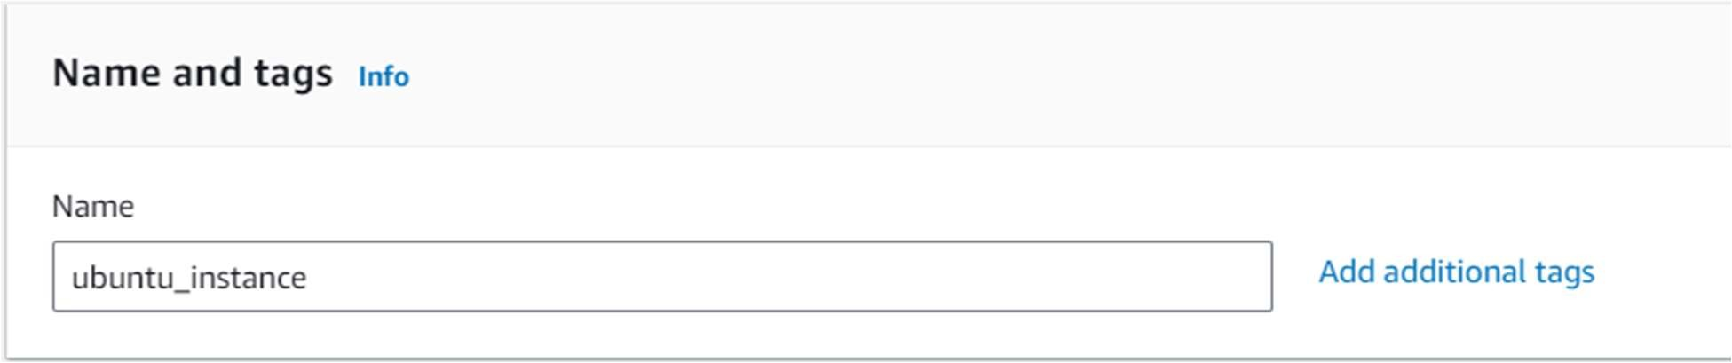

1. Choose AMI -> select Ubuntu

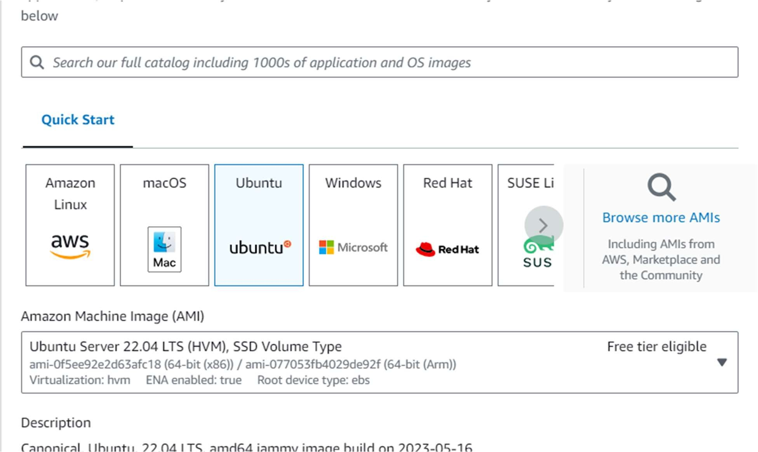

1. Create key-Pair :
   1. click on Create new key pair

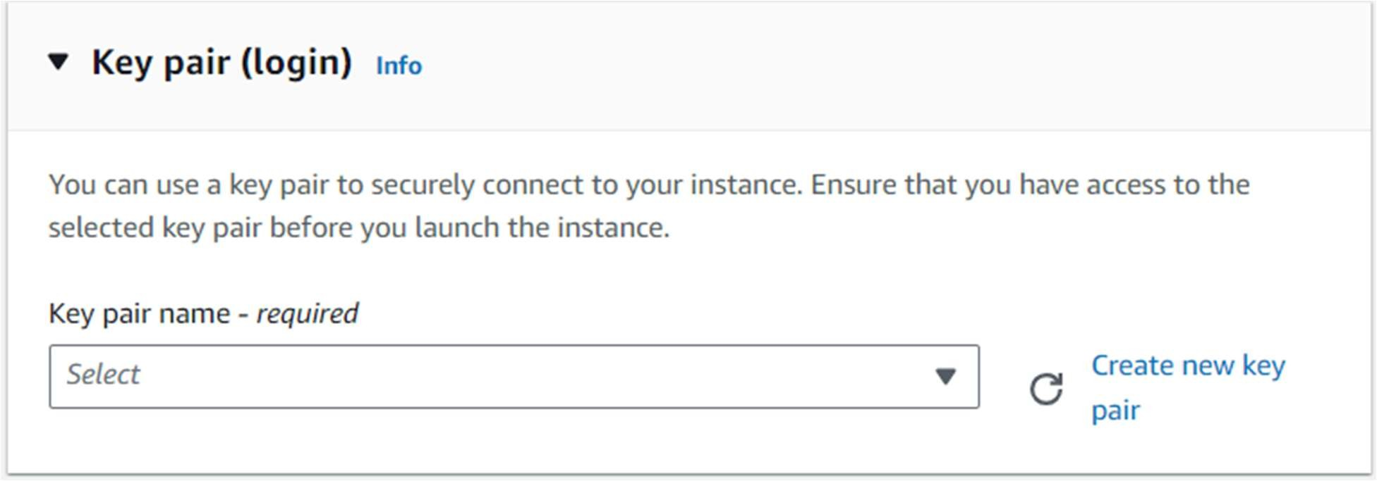

* 1. Enter a Create Key Pair name > select .pem as a private key ﬁle format >click on Create key pair

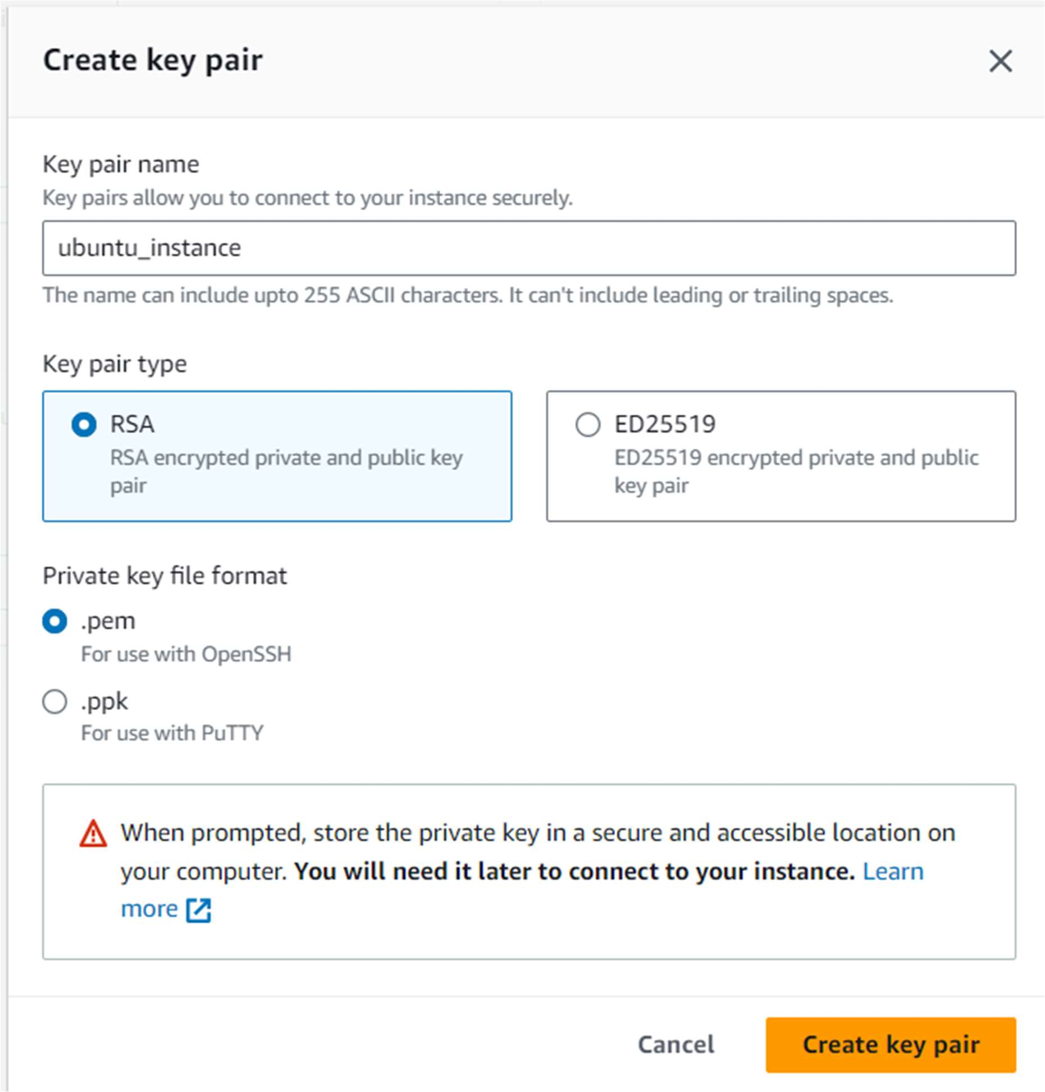

1. Launch Instance

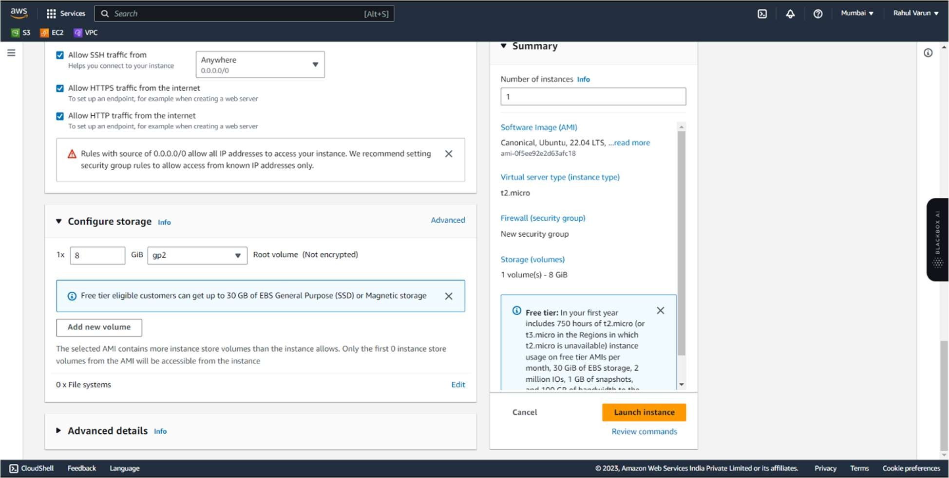

Step 2. Next step is to connect our system with Ec2 instance or server .

Open Powershell > choose a directory where we have saved the pem ﬁle > and execute this command

ssh -i "ubuntu_instance.pem" [ubuntu@ec2-3-108-228-95.ap-south-1.compute.amazonaws.com](mailto:ubuntu@ec2-3-108-228-95.ap-south-1.compute.amazonaws.com)

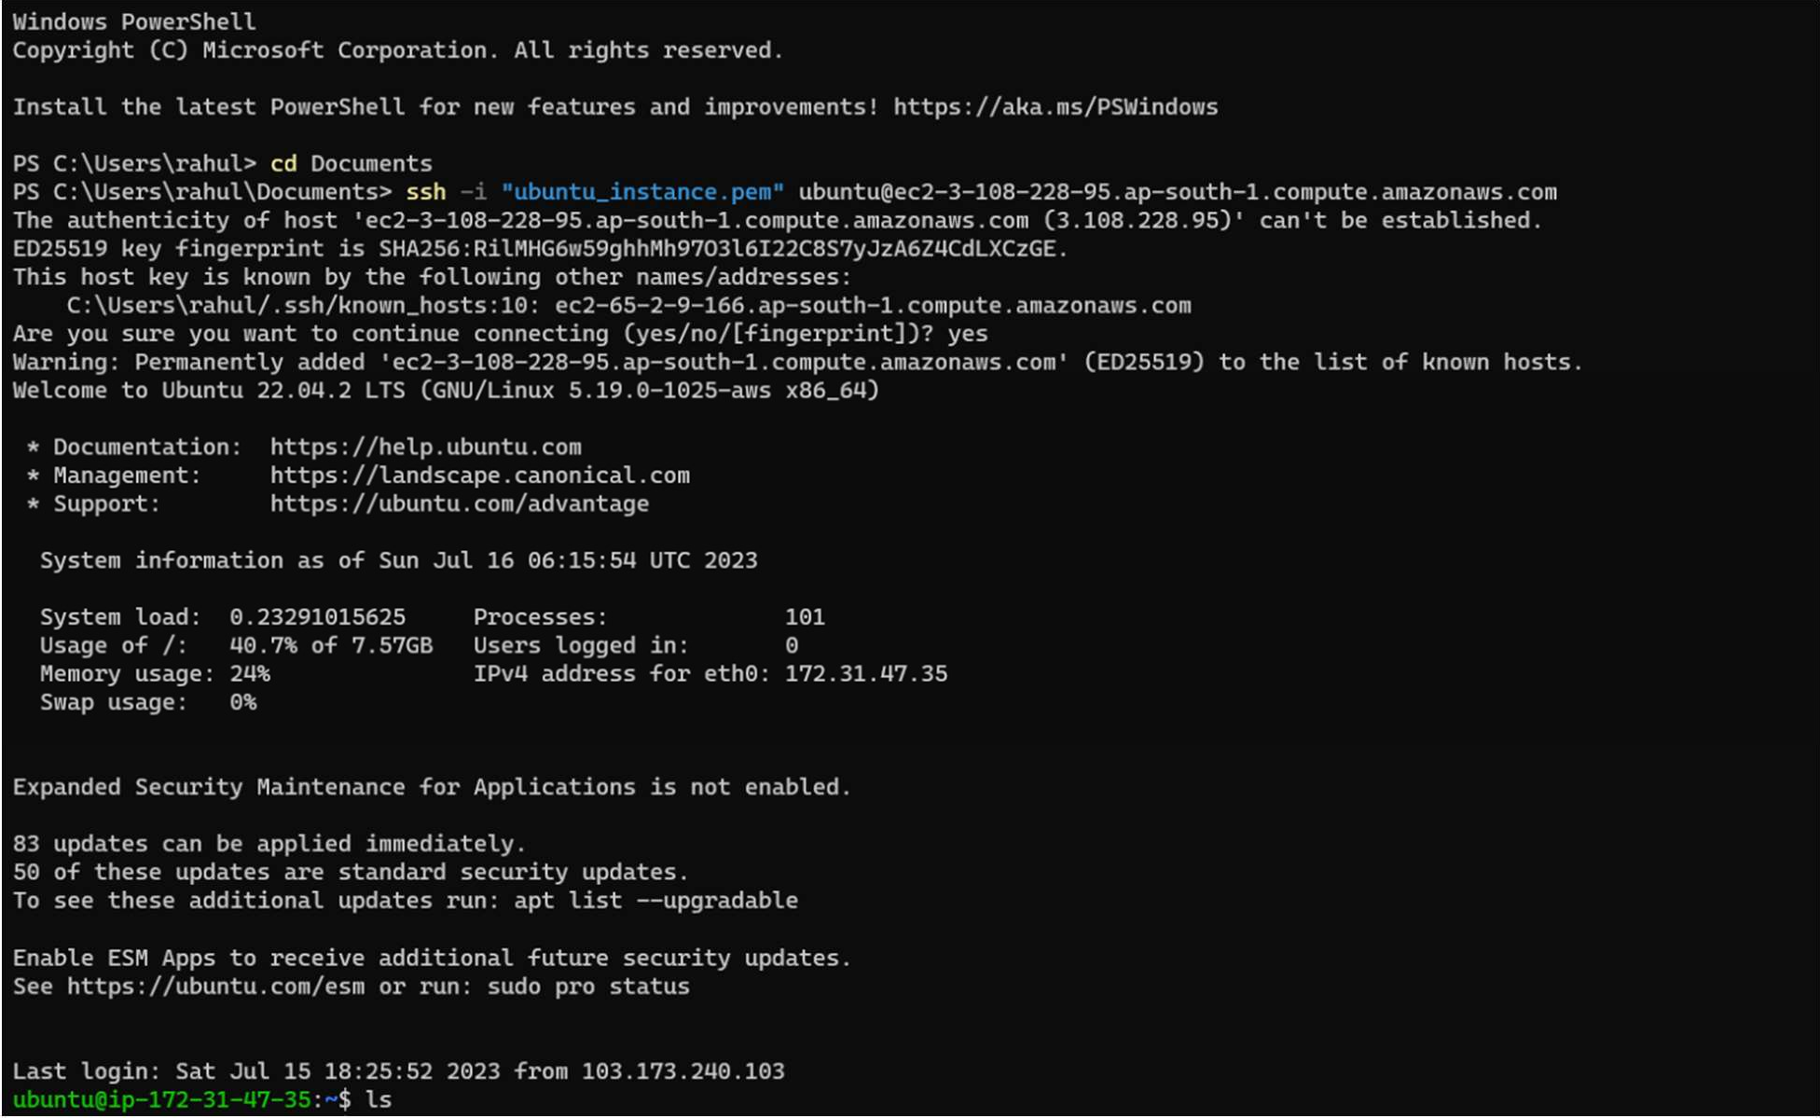

Step 3: Install Apache Server to deploy our server Execute following code :

Sudo su : to get Admin privileges

sudo apt install apache2 : to install apache web server

sudo systemctl status apache2 : to Check The status of server

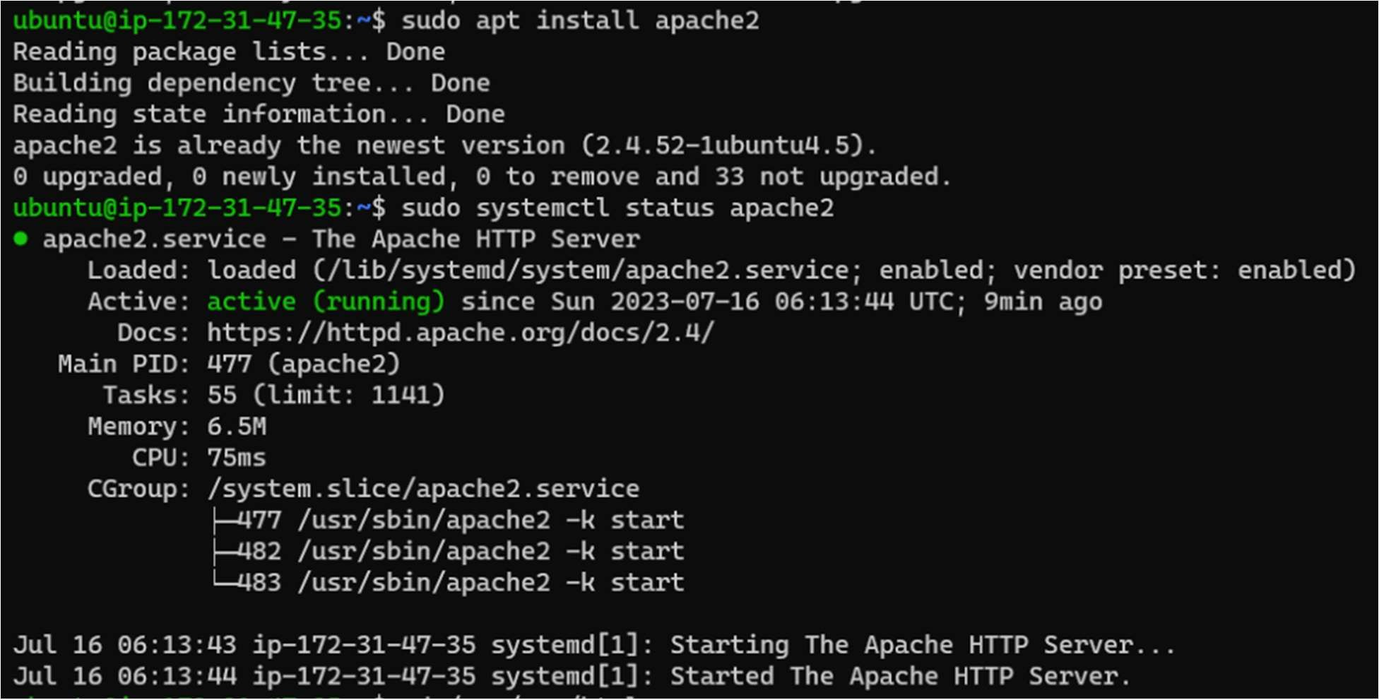

Assignment 2: Deploy a web page using EC2 instance

Step 1. Add Html page on var/www/html directory to run webpage on server

Method: 1. Change your current directory of ec2 to var/www/html and create Html ﬁle using this command Nano name_ﬁle.html

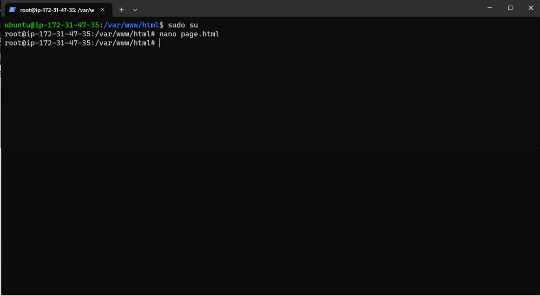

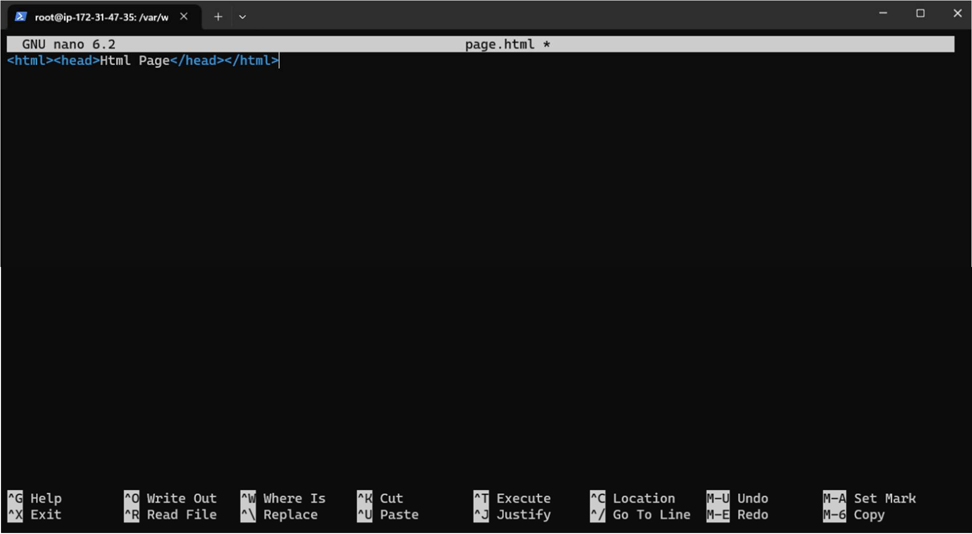

Method 2: Transfer Your local system ﬁles or directory to our ec2 instance using SCP(secure copy )

scp -i pemﬁle ﬁle_to_transfer ec2-user@Public_DNS:~ but Remember to put both ﬁle in the same directory:

Output:

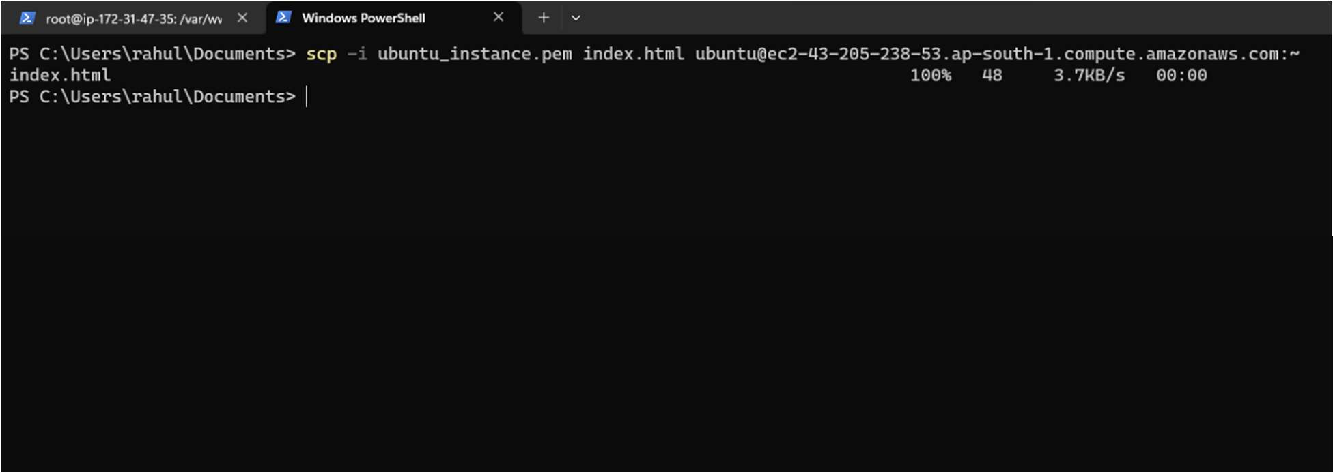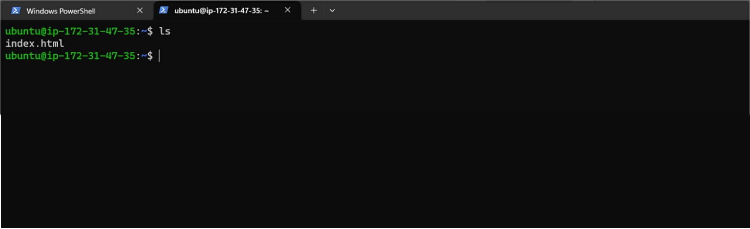

As we can see we have received a ﬁle > Now we will move this ﬁle to var/www/html directory to run web page

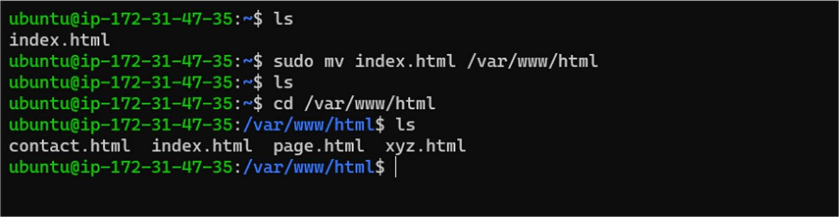

FINAL OUTPUT :

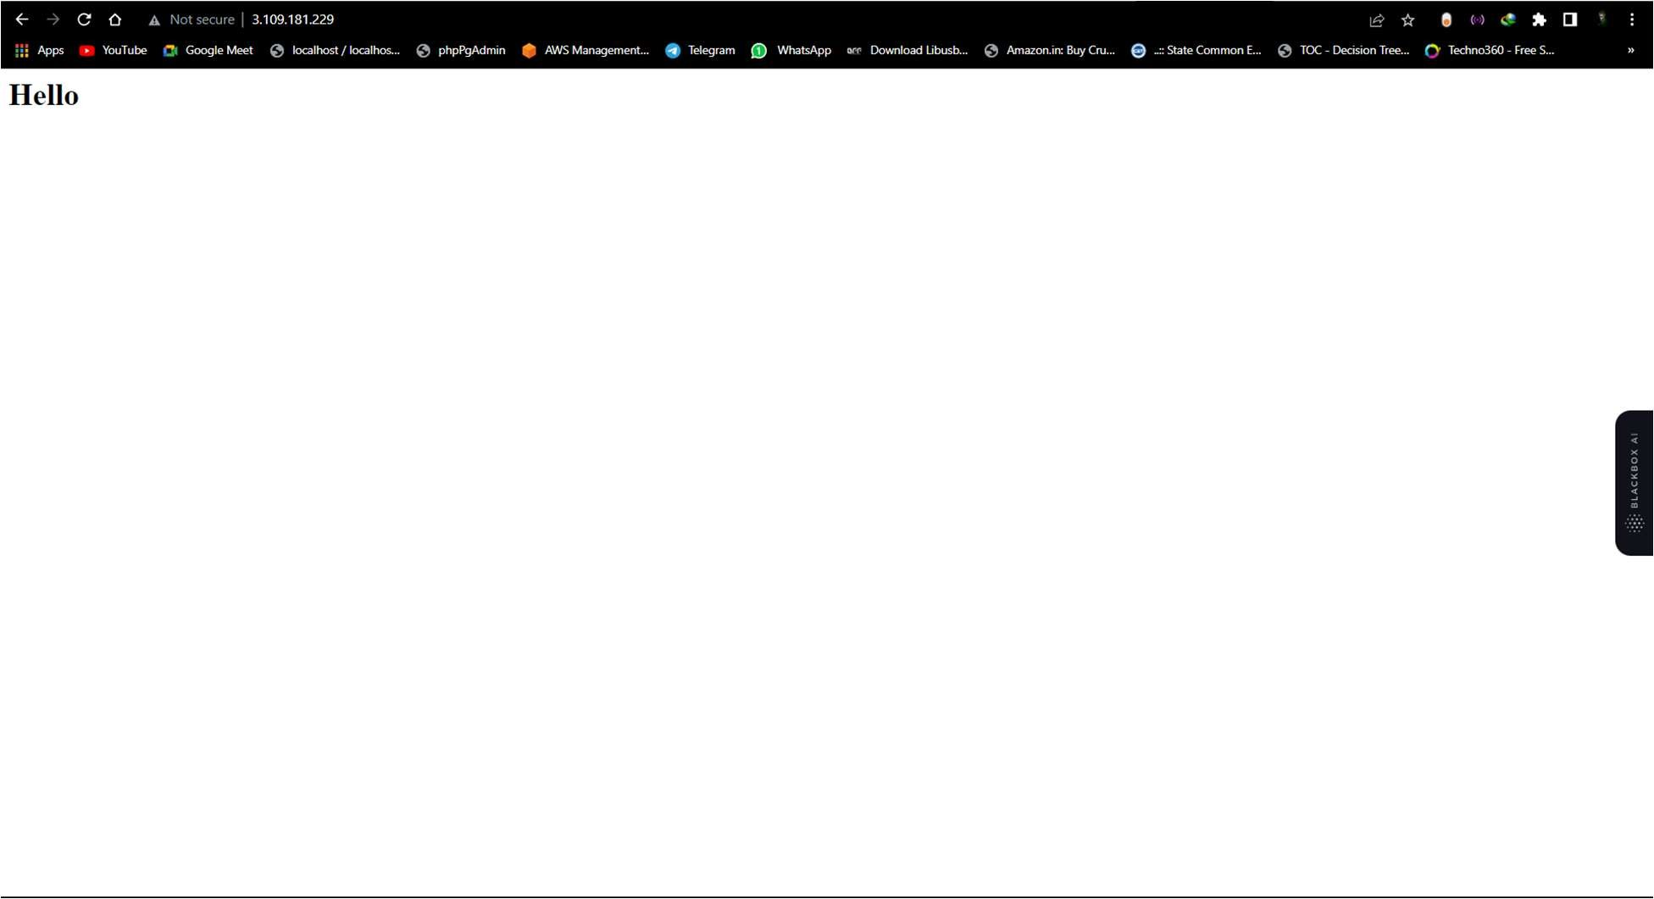

Assignment 3: Deploy a Multiple web page on single EC2 instance Step 1: Add Multiple web pages files or Folder

Here I am using SCP to transfer my web pages from my system to Ec2 instance

scp -i ubuntu_instance.pem web1.zip ubuntu@ec2-43-205-238-53.ap-south-1.compute.amazonaws.com:~

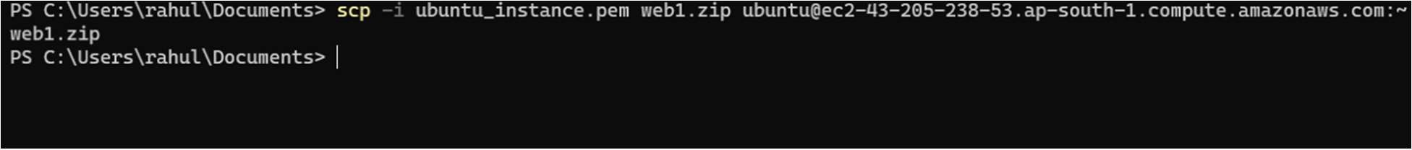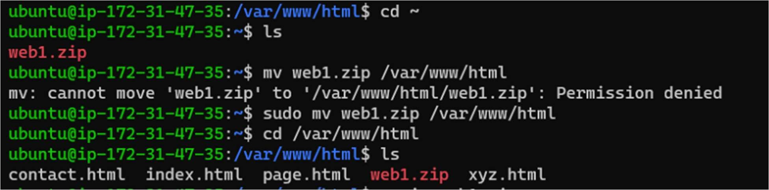

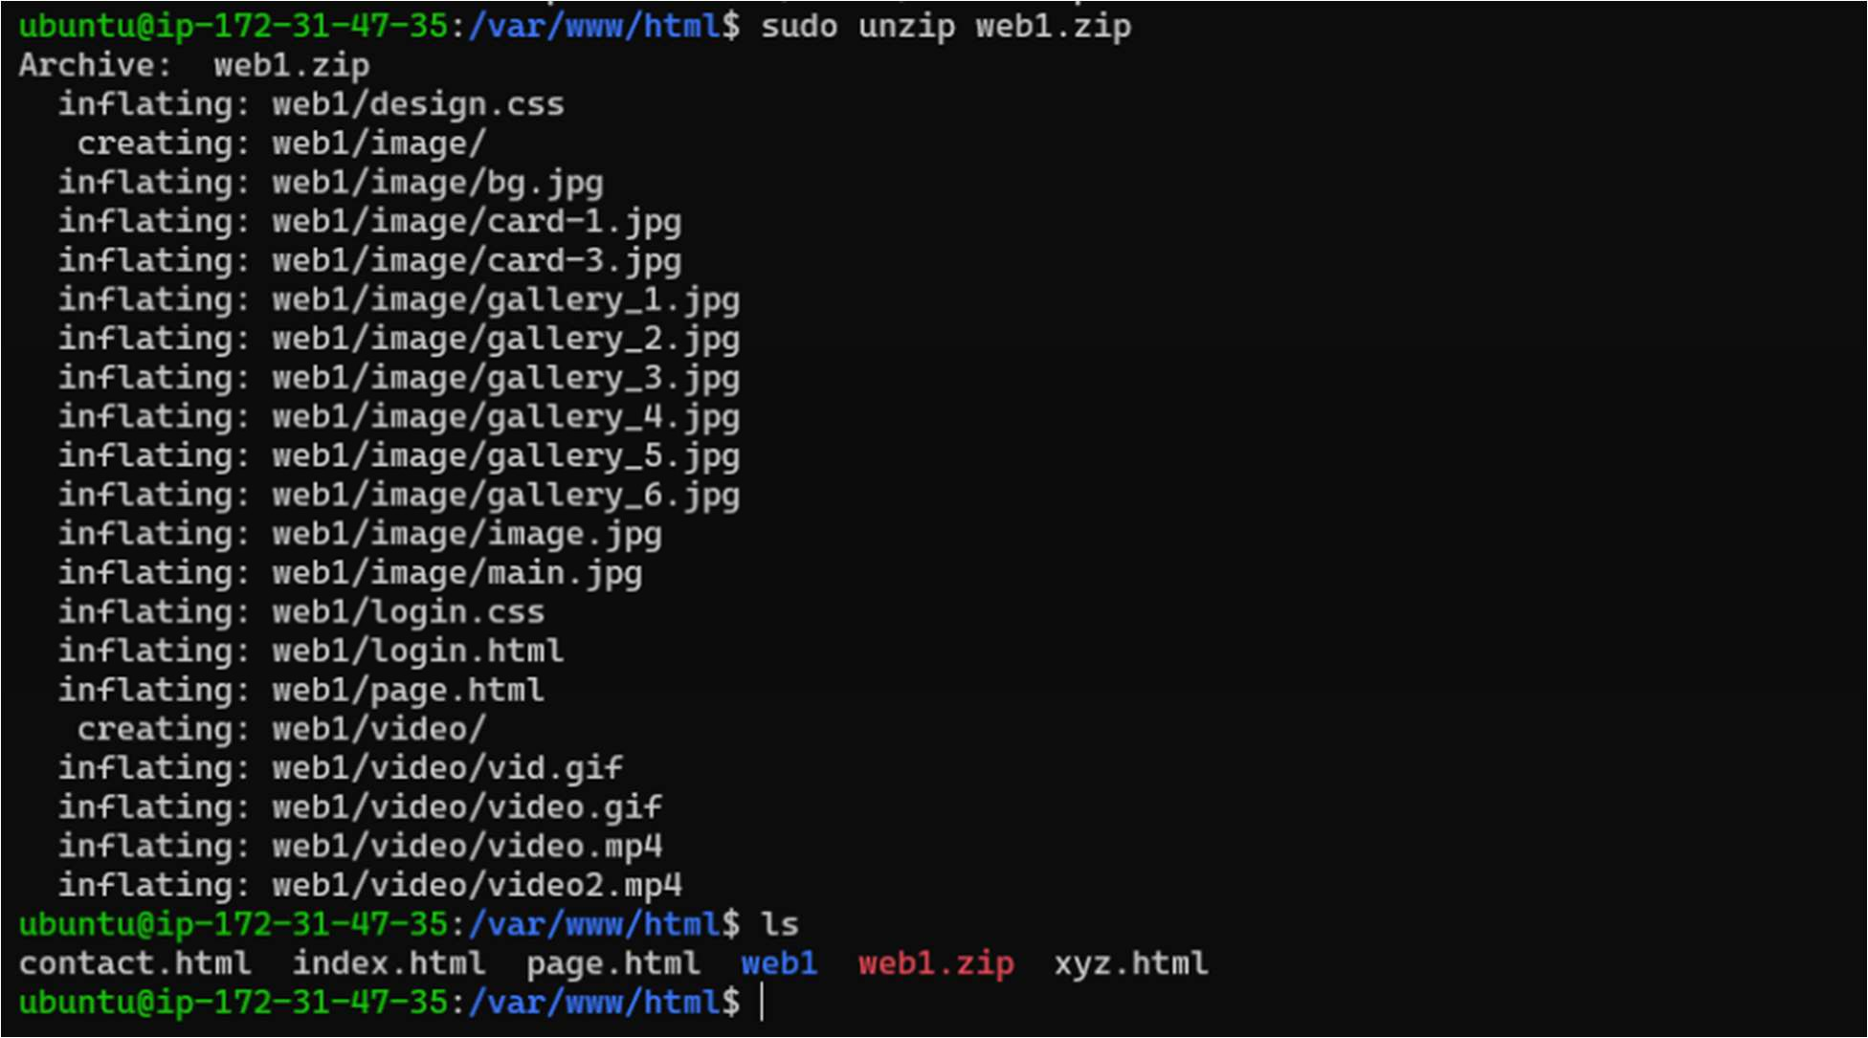

Running web pages on server:

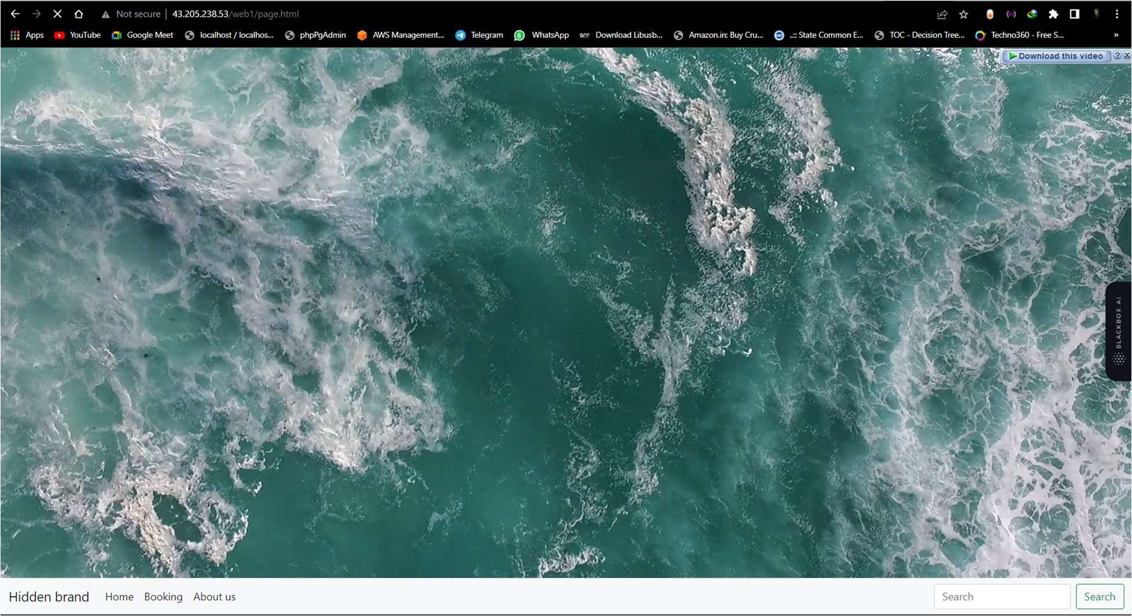

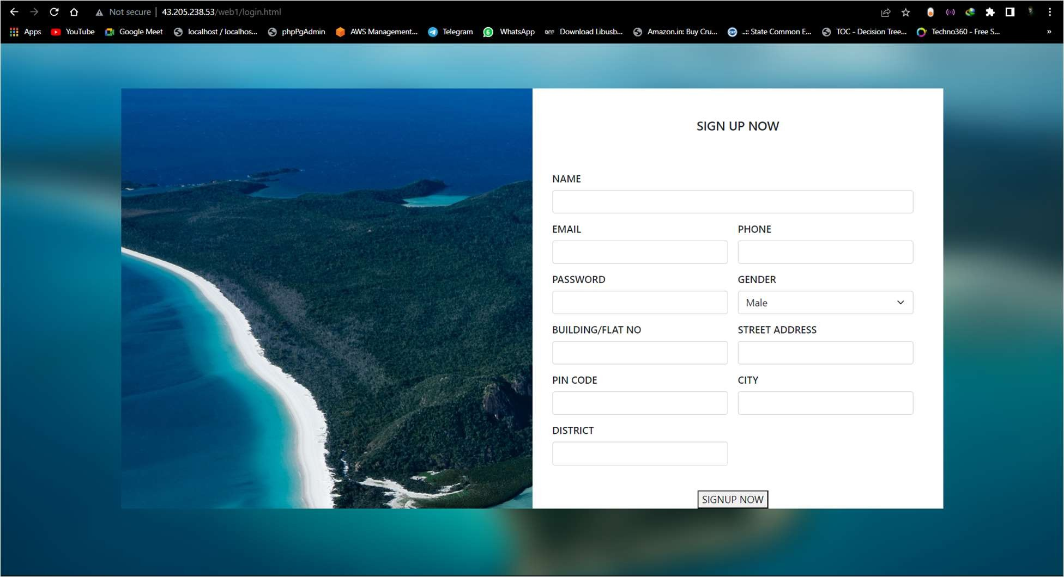

Assignment 4 : Deploy LAMP Stack on Linux

Now from the LAMP stack ﬁrstly We will be Installing Apache Server: Step 1.

Execute following code :

sudo apt install apache2 : to install apache web server

sudo systemctl status apache2 : to Check The status of server

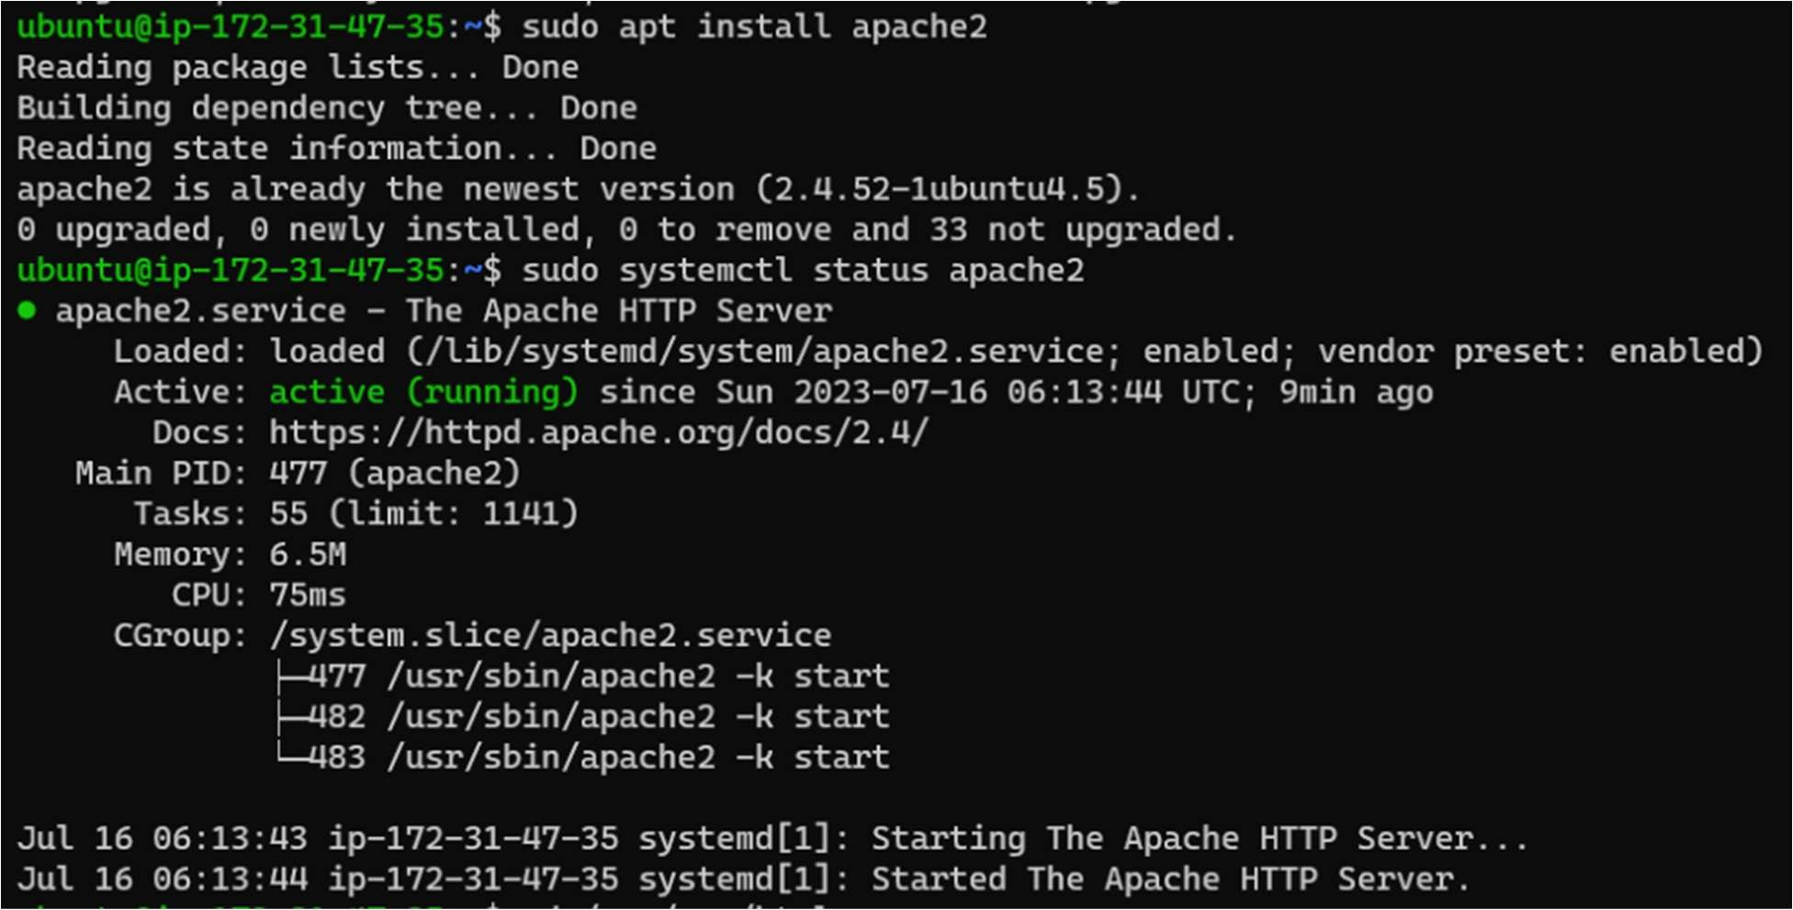

Now that Apache is Installed . Step 2:

Now We’ll install Mysql Server

Execute The following Commands to Install Mysq:

* Sudo apt install mysql-server -y
* mysql

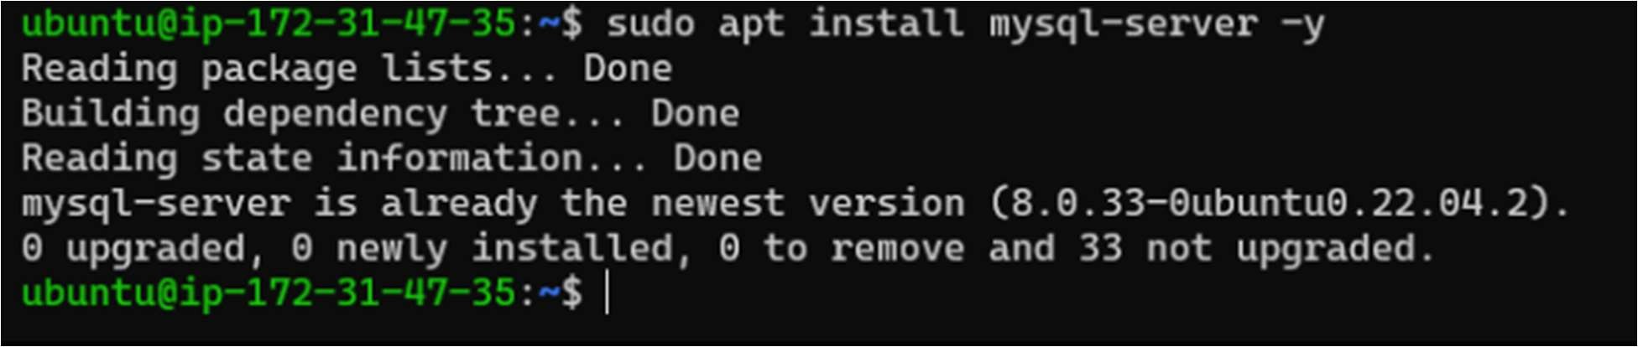

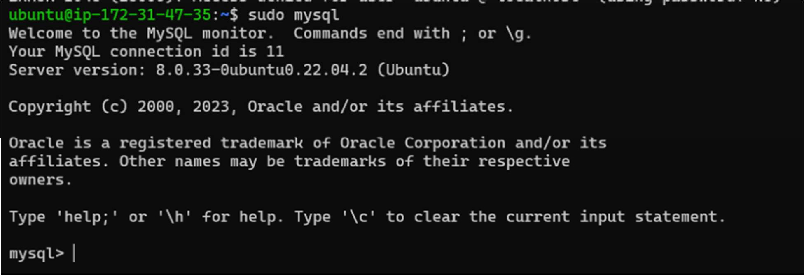

As we have successfully installed apache server and Mysql Step 3 : now we will install PHP:

Execute The following Command to install Php

sudo apt install php libapache2-mod-php php-mysql

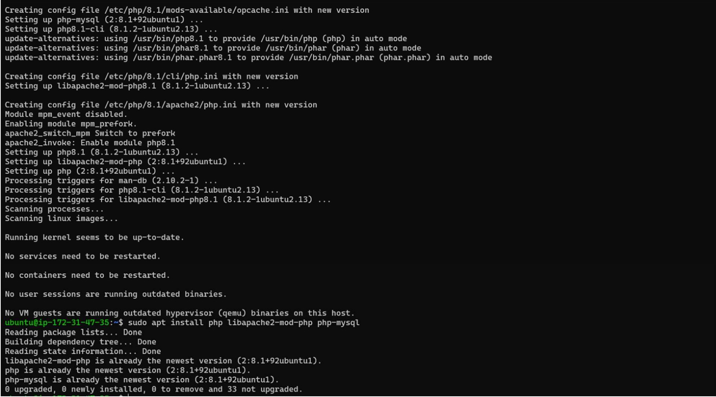

Now all the Lamp Stack is installed Step 4:

Last step is to deploy php page to check whether its working or not:

We will add php page inside this directory /var/www/html

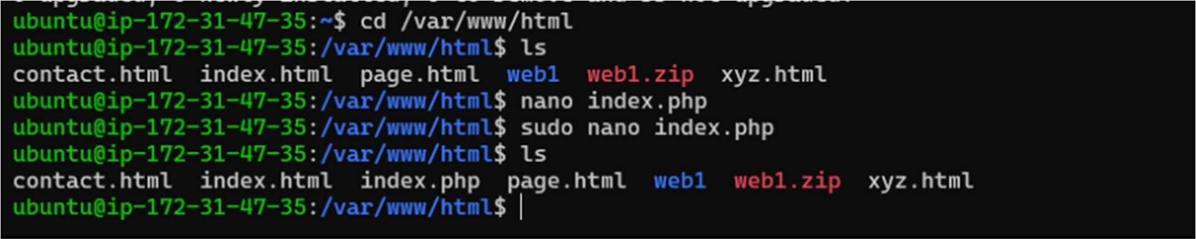

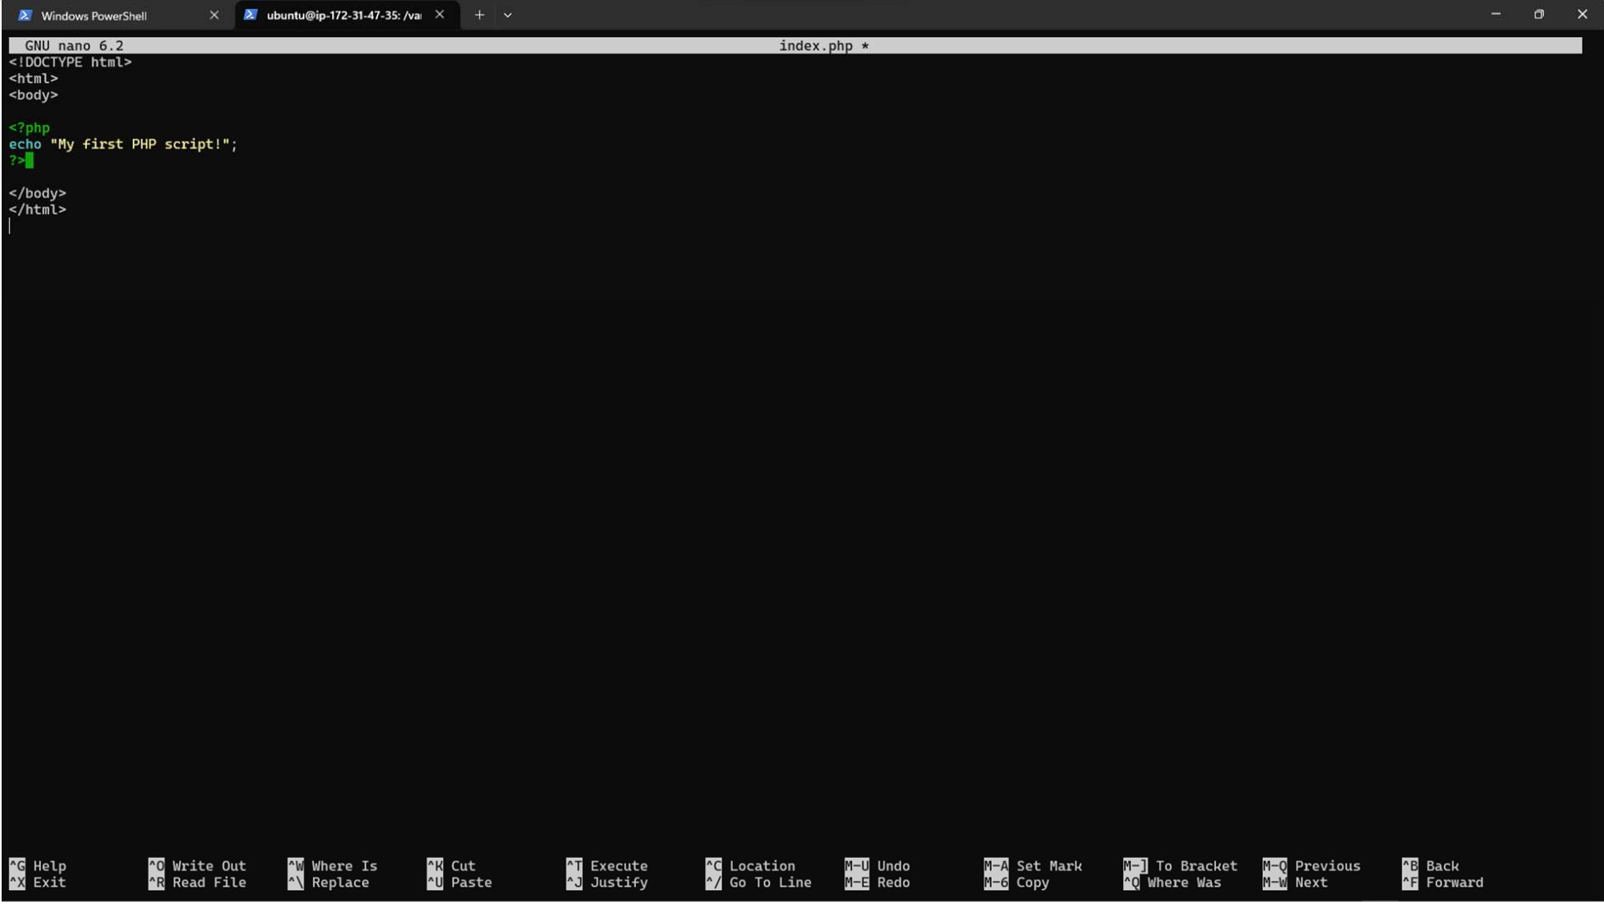

Output: As we can see our PHP page hosted successfully:

